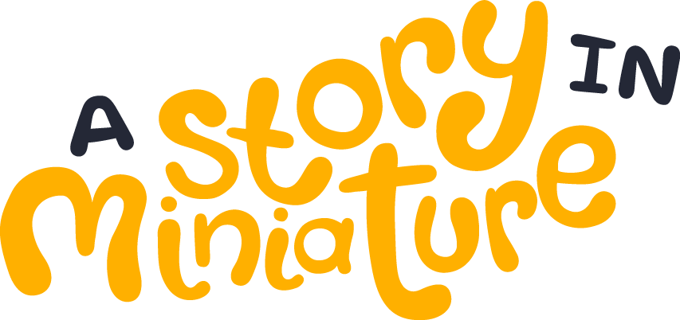

A Story in Miniature: 2026 VATE Writing Competition

Terms and conditions of entry
- Judges’ decisions will be final and no correspondence will be entered into.
- Plagiarism will not be tolerated. You will be automatically disqualified from the competition if any plagiarised work is submitted.
- Entries generated using AI are prohibited. Entries found to be generated using AI will be disqualified. Minor use of AI for checking grammar and spelling is permitted.
- Entries must not include material that infringes on the copyright of anyone else.
- Winners will be announced via email to the VATE membership.
- Entrants may be asked to assist in media publicity in the form of comments, online interviews and/or photographs.
- All entrants agree to their stories being published on the VATE website, in Idiom, and to VATE using them in teaching and learning material.
- Copyright remains with the author, however, VATE reserves the right to have any entry published, reproduced or publicised for promotion purposes.
Submissions
Complete the below entry form and submit your story and completed entry form to writingcompetition@vate.org.au. Entries of 300 – 500 words are due by 4pm Friday 18 September 2026.

Please print clearly. Typos can prevent you being contacted about your story.

Name
School
Category of entry
Contact email
Title of entry

Teacher endorsement (for student entries)
Name
Email
I confirm that the details of the student named above are correct and that the short story submitted is the student’s own work.

Signed: Date:

Declaration
By submitting this form, I confirm that I have read and agree to the A Story in Miniature writing competition entry requirements and accept the terms and conditions. I declare that the work submitted is my own.

